Richard Hill CE Primary School
EYFS Curriculum Mapping and Sequencing
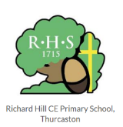
Our EYFS Big Picture
Here at Richard Hill CE Primary School, our curriculum aims to be:
One that engages both the children and parents and builds on strong relationships. One where children are supported to explore, take risks, enjoy learning and build a strong foundation for further schooling through a powerful play-based environment. One that builds on children’s interests but also develops these and introduces new ideas, ambitious vocabulary, inspiring topics and new opportunities. One where children are happy and celebrated for being themselves, no matter their ability, need or SEND. One where staff feel supported and can make decisions that best support our children through skilled, high-quality interactions that create sustained thinking. One that develops the children’s understanding of what it means to be part of our Richard Hill community and the Christian Ethos.

How is our EYFS curriculum designed to achieve this?
- EYFS Curriculum on a page
- Characteristics of Effective Learning
- Cultural Capital and British Values
- Our Christian Ethos and Values
- LTP and Sequencing including
Memorial Experiences
EYFS Literature Spine
Music Unit Overviews
RE “children can” statements and Progression
Prime Areas “I can” statements
Specific Areas “I can” statements
- EYFS “Point of Year” Skills Progression
- Computing and Media Links and Sequence
- PE Sequence

EYFS Curriculum on a Page


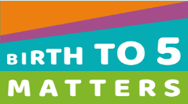
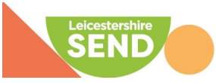

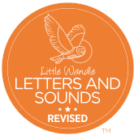




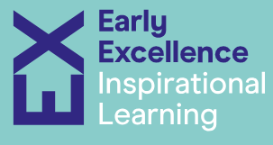

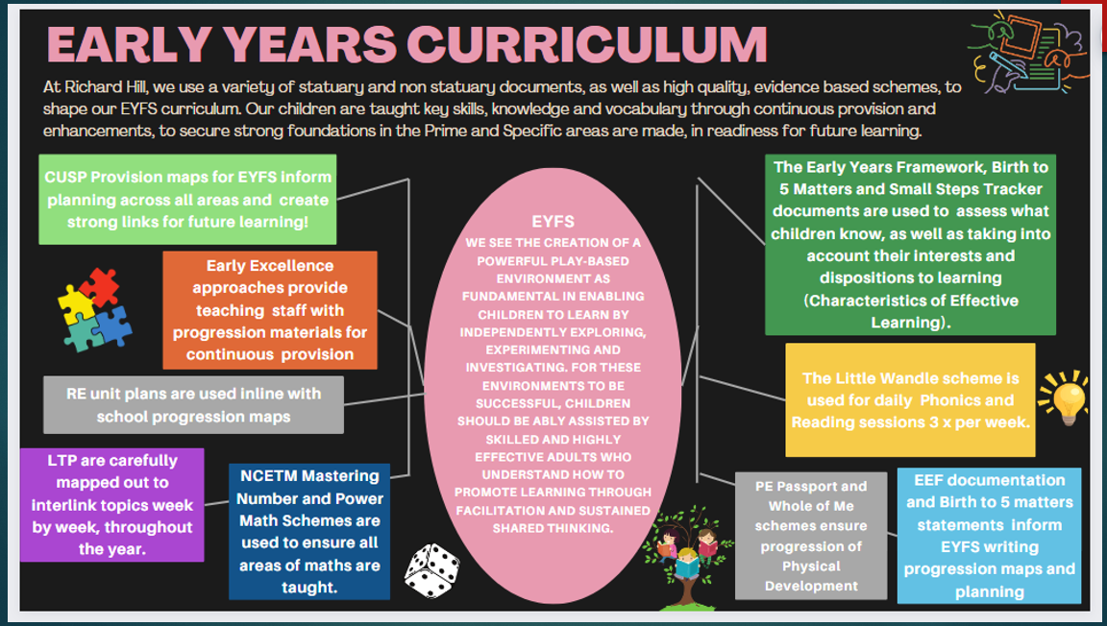

Characteristics of Effective Learning
The three Characteristics of Effective Learning are interspersed throughout our Curriculum. The continuous provision, enhancements and adult led sessions are developed and adjusted accordingly using the below statements:
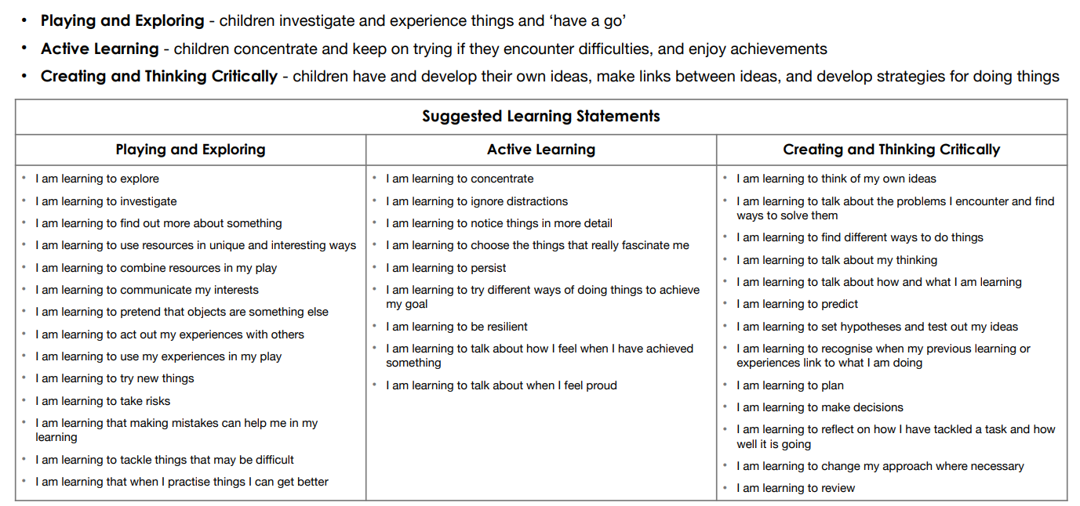

Planning for Learning in the Early Years: An essential tool for effective practise. Simmons & Morris (December 2020 Third Ed)

Cultural Capital and British Values
At Richard Hill, we believe cultural capital is unique for every child in our EYFS provision and it is the centre of our education. We build on and celebrate existing experiences and offer new opportunities for children to increase their knowledge, understanding and skills. By using observations and knowledge of the children, we plan opportunities that benefit them the most.
Here are some of the ways we do this:
- Inviting local visitors in to speak to the children linking to topics
- Questionnaires for parents to complete to understand their child’s interests at home so we can build on them at school
- Using our Diversity book spine to ensure our children are hearing stories about people from many different backgrounds and learning to respect people who may be different to themselves
- Trips around our local area and Leicestershire
- A frequently changed role play area, where children can role-play new experiences
- Exploring music and songs from different cultures
- Celebrating festivals and cultural events e.g. Diwali and Nativity showcase to parents
- Understanding the importance of being active and engaging in the outdoor environment
- Children sharing news about what they do outside of school with their families.
- Exploring new vocabulary through stories, poems and non-fiction texts
- Topic based writing tasks provide purpose and motivation
- Engaging in Science experiments and Maths problems that promote awe and wonder


The teaching of British Values is embedded into our curriculum. We encourage the children to help others, respect others’ beliefs, cultures and differences, make decisions, understand right from wrong and value others’ opinions.
We teach these values in some of the following ways:
Through stories from our Diversity Spine
Through our RE teaching
Through our PSED teaching
Daily voting for a “Class Monitor” and choosing a helper
Voting for stories
Voting for a role play area focus
PD CUSP links – Rosa Parks, Amelia Earhart, Mae Jemison (please see planning for me links)
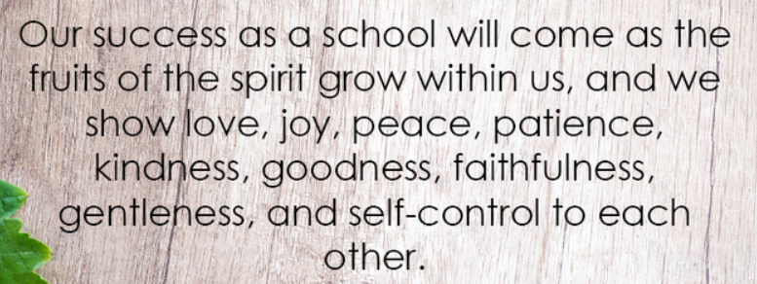
Our Christian Vision and Values
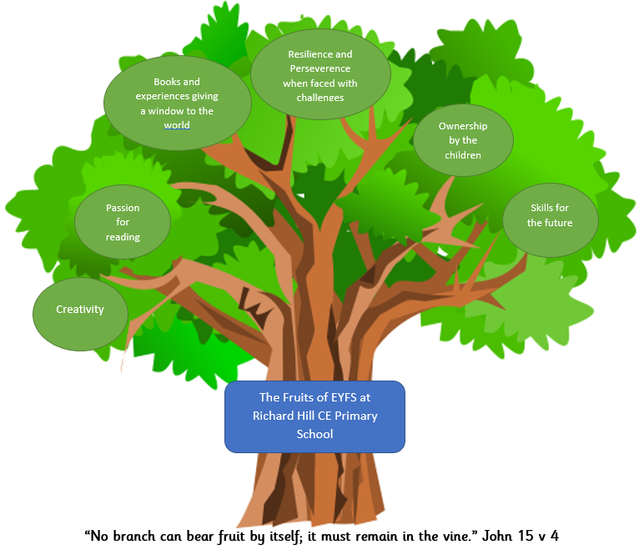
We believe, as did our founder Richard Hill, in helping prepare the children for the challenges and opportunities of life. In 2020 our theologically rooted Christian Vision was chosen in partnership with all our stakeholders.
“You shall know them by their fruits.” Matthew 7:16
In the EYFS, we teach the children these values progressively. By doing this, we aim to ensure that the children have a deep understand of the importance of each value. By the end of Foundation, the children can talk about the values and identify when they are applying them in their everyday lives.

Early Learning Goals:
The Early Years Foundation Stage (EYFS) sets standards for the learning, development, and care of children from birth to 5 years old. The EYFS framework includes 17 early learning goals (ELGs) across 7 areas of learning. Teachers assess each child against these ELGs to determine if they are meeting the expected level of development by the end of the EYFS¹.
The Goals in yellow much be achieved for a child to reach a “Good level of Development” (GLD).
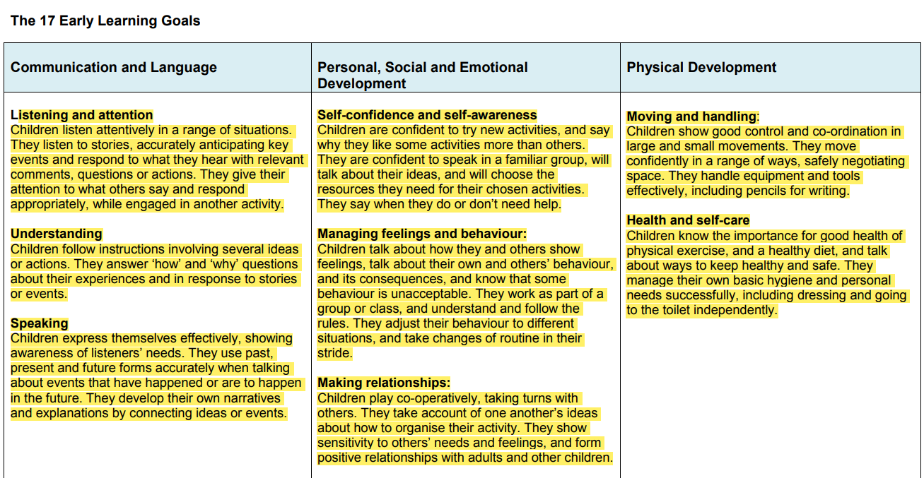
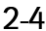
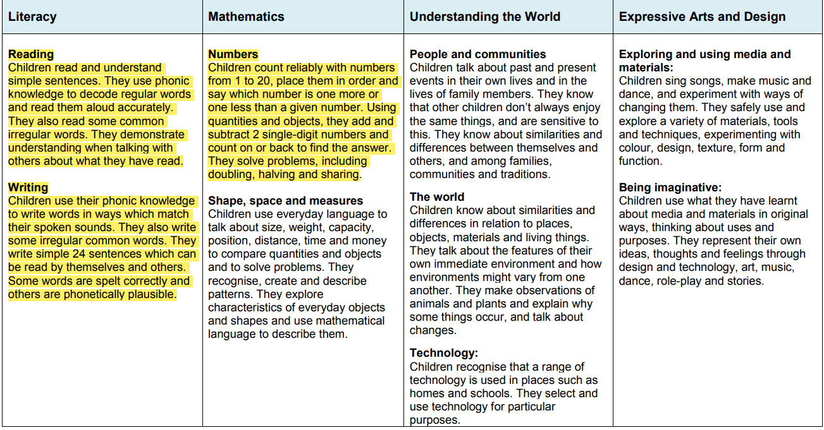

LTP and Sequencing 2024-2025
 | Autumn 1  8 weeks |  | Autumn 2  8 weeks |  | Spring 1  6 weeks |  | Spring 2  7 weeks |  |  | Summer 1  4 weeks |  | Summer 2  5 weeks
Week 1 | WB 26th August  All About Ourselves  Settling Week |  | WB 28th October  Diwali (1st November)  The Best Diwali Ever DS |  | WB 6th January  Seasons – IT link (cameras)  Winter experiences- snow and ice |  | WB 24th February  Seasons IT link (cameras)  Spring Growth – plants  Art:-Famous Artists: Van Gogh  Ramadan/Eid (28th Feb)  In my Mosque DS |  |  | WB 28th April & 5th May  London  Paddington  Geog: House of the King, London capital City  Geog: Naughty Bus  History: Past and Present  DT: Vehicles IT link (beebots)  Sci: testing a coat for Paddington |  | WB 2nd June  Sci: Looking after our bodies  Funny Bones  (Big EYFS Focus)
Week 2 | WB 2nd September  Summer Holidays  Summer  The Colour Monster  I love me! DS |  | WB 4th November  Bonfire Night (5th November)  Little Glow DS  Autumn walk – IT link (camera)  Autumn collecting  Sci: Planting Bulbs |  | WB 13th and 20th January  Toys  Hist: Past and Present  IT link (beebots) |  | WB 3rd March  Pancake Say - Shrove Tuesday (4th March)  World Book Week (6th March|)  Growth – animals |  |  |  |  | WB 9th June  Plants  The Enormous Turnip  Sci: Planting different seeds  Father’s Day Crafting (15th June)
Week 3 | WB 9th September  My family  My Magic Family DS  Sci: Pets |  | WB 11th November  Remembrance (11th November)  Art: The Dot |  |  |  | WB 10th March  British Science Week (WB 10th March)  Ava Twist Scientist DS  Geo: “Space, Earth & Planets”  Tim Peake - Astronauts |  |  | WB 12th and 19th May  Transport and travel  Shopping  Pablo Goes Shopping DS  Geog: Amelia Earhart  Local area visit into Anstey |  | WB 16th June  In the garden  Oliver’s Vegetables
Week 4 | WB 16th September  Different types of families (Diversity Book Spine)  All are welcome DS |  | WB 18th & 25th November  Animals  Dear Zoo  Owl Babies  Handa’s Surprise  DT: Baskets  Geog: Naming features with animals beach, farm, woodland |  | WB 27th January  Chinese New Year (29th Jan) |  | WB 17th & 24th March  Eco-recycling/The Environment  Geog: Michael Recycles Story  DT: Boats from Recycling  (Big EYFS Focus)  DT: Cakes for mother’s day (30th March) |  |  |  |  | WB 23rd June  Minibeasts  Tad  DT: Bug Hotels
Week 5 | WB 23rd September  Our School  Church visit |  |  |  | WB 3rd February  Houses and Homes – IT link (devices)  Trad Tale: Three Little Pigs  Trad Tale: Goldilocks and the Three Bears |  |  |  |  |  |  | WB 30th June February  Summer changes IT link (cameras)
Week 6 | WB 30th September  Black History Month  Hist: Rosa Parks  Art: Kente cloth |  | WB 2nd December  Africa Comparison  Handa’s Surprise |  | WB 10th February  Valentines Day Baking  Famous Artists: Andy Goldsworthy |  | WB 31st March and 7th April  Easter (20th April)  Lifecycles – Chicks  Church visit |  |  |  |  | WB 7th July  Short 2 day week
Week 7 | WB 7th & 14th October  Harvest festival (11th October)  Trad Tale: The Little Red Hen  Pattan’s Pumpkins DS |  | WB 9th and 16th December  Christmas  Nativity  Church Service – Christmas
Week 8
Sequencing

 |  | Autumn 1 |  | Autumn 2 |  | Spring 1 |  | Spring 2 | Summer 1 |  | Summer 2
Memorable Experiences |  | Visitors – different occupation  Tour of the School  Local Area Walk -  Thurcaston  (including Church)  Harvest Church Service |  | Autumn walk - Thurcaston fields  Nativity play  Visitor – Diwali  Diwali Assembly  Christmas Church Service |  |  |  | Easter Church Service | Local Area Visit – Anstey (café/bakers/grocery/ opticians visit)  Trip to the Great Central Railway |  | Visitor – nurse/dentist etc  Summer Picnic  Seaside Trip
EYFS Literature Spine  Books needed*  Old Bear – toys*  Rosie’s Walk*  The Man on the Moon*  Each Peach Pear Plum*  The Dot – CUSP  The Acorn*  Frog on a Log*  Monkey Puzzle* |  | The Little Red Hen  The Colour Monster  Hair Love (DS)  My Skin Your Skin (DS)  I Love Me (DS)  So Much (DS)  My Magic Family (DS)  All are Welcome (DS)  Pattan’s Pumpkins (DS)  Making friends  Bunny Stories – emotions*  Seasons Text -Autumn  The Giant Jam Sandwich  Goldilocks and the Three Bears  The Magic Porridge Pot  The Gingerbread Man  Rumpelstiltskin  Bible Stories –  Noah’s Arc  Jelly Fish Story (Creation)  Little Wandle – Poetry & Rhyme  Each Peach Pear Plum* |  | Dear Zoo  Owl Babies  Handa’s Surprise  Little Glow (DS)  The Best Diwali Ever (DS)  Rama and the Demon King  The Dot – CUSP*  The Acorn – autumn*  Titch- plants  Animal Information Books  Jack and the Beanstalk  Billy Goats Gruff  The Elves and the Shoemaker  Bible Stories –  Feeding of the 5000  Precious Pearl (Creation)  Christmas Story  Little Wandle – Poetry & Rhyme  Duck in a Truck |  | One Snowy Night - Seasons  Old Bear – toys*  Chicken Licken  10 Chirpy Chicks  Elmer  Toys information books  Traction Man - toys  Seasons Text - Winter  Chinese New Year – online story  The Three Little Pigs  Little Red Riding Hood  Hansel and Gretal  The Ugly Duckling  Bible Stories -  Two Brothers  Jesus’s Friends  Little Wandle – Poetry & Rhyme  Frog on a Log – rhyming* |  | Supertato  We’re Going on an Easter Egg Hunt  Seasons Text - Spring  The Big Pancake – online story  Ava Twist Scientist (DS)  The Man on the Moon*  The Loon on the Moon  Look Up (DS)  In my Mosque (DS)  Baby Animals Information Book  Dinosaurs and All that Rubbish  Michael Recycles - CUSP  Recycling – Information  Van Gogh and the Sunflower – CUSP online story  We’re Going on a Bear Hunt  Bible Stories - Easter Story  Little Wandle – Poetry & Rhyme | The Tower Bridge Cat  Paddington Bear - CUSP  Spot goes to the Farm  Monkey Puzzle*  Pablo Goes Shopping  Rosie’s Walk*  Don’t Forget the Bacon  Buses – flap book  London City Skyline  Busy London  We must Completely go to London  My London Alphabet  Princess and the Pea  Puss in Boots  Disney Tradition Tales (e.g. Cinderella/sleeping beauty)  Bible Stories - retrieval  Little Wandle – Poetry & Rhyme |  | Funny Bones - CUSP  Oliver’s Vegetables  The Enormous Turnip  Grandfather’s Island – transition text into KS1  The Hungry Caterpillar  Tad  Ten Tiny Tadpoles  Information texts – bodies*  Seasons Text – Summer  Burglar Bill  Bible Stories – retrieval  Little Wandle – Poetry & Rhyme
Shared Writing Texts
At Richard Hill, texts used in our Literature spine are carefully planned to link with topics and key learning. The texts in bold are used as stimulus for Reception children’s Shared Write lessons. We believe reading these books to the Nursery children, provides them with important prior learning in readiness for Reception lessons.

Music |  | Harvest singing  Nursery rhymes |  | Christmas songs  Diwali songs and dancing |  | Chinese New Year- Dragon Dance |  | Easter  Songs and rhymes | Visitor in to play songs  CS- piano whilst they sing. |  | Dance: PE  Thinking about solo and group singing and dancing
RE |  | Foundation 1  Children can:  - engage creative play, make-believe, role play, dance and drama  - dress up and act out scenes from stories, celebrations or festivals  - make and eat festival food  - talk and listen to each other; hear and discuss stories of all kinds, including religious and secular stories with themes such as goodness, difference, the inner world of thoughts and feelings, and imagination  - explore authentic religious artefacts, including those designed for small children such as ‘soft toy’ artefacts or story books  - see pictures, books and videos of places of worship and meeting believers in class  - listen to religious music  - start to introduce religious vocabulary  - work on nature, growing and life cycles or harvest  - seize opportunities spontaneously or linking with topical, local events such as celebrations, festivals, the birth of a new baby, weddings or the death of a pet starting to talk about the different ways in which people believe and behave, and encouraging children to ask questions.
 |  | Foundation 2
 |  | Autumn Term |  |  |  | Spring Term |  |  | Summer Term
 |  | Children can:  - Talk about people who are special to them  - Say what makes their family and friends special to them  - Recall simply what happens at a traditional Christian festival (Christmas)  - Begin to recognise the word ‘incarnation’ as describing the belief that God came to Earth as Jesus  - Retell religious stories, making connections with personal experiences (stories in EYFS Literature Spine)  Celebrations:  Harvest  Bonfire Night  Diwali  Remembrance Day |  |  |  | Children can:  - Recognise and retell stories connected with celebration of Easter (stories in EYFS Literature Spine)  - Say why Easter is a special time for Christians  - Talk about ideas of new life in nature  - Recognise some symbols Christians use during Holy Week, e.g. palm leaves, cross, eggs, etc., and make connections with signs of new life in nature  - Talk about some ways Christians remember these stories at Easter.  Celebrations:  Chinese New Year  Ramadan and Eid  Shrove Tuesday  Easter |  |  | Children can:  - Talk about some religious stories (stories in EYFS Literature Spine)  - Recognise some religious words, e.g. about God  - Identify some of their own feelings in the stories they hear  - Identify a sacred text including the Bible, Torah, Qur’an, The Bhagavad Gita  - Talk about some of the things these stories teach believers (for example, what Jesus’ story about the ten lepers teaches about saying ‘thank you’, and why it is good to thank and be thanked) etc.
Progression and Mastery in the Prime and Specific Areas:
At Richard Hill, we understand that children will progress and master areas of the EYFS curriculum at different points throughout the year. The progression maps below demonstrate when skills are specifically taught by an adult as an enhancement. However, as we know that children are unique and will develop these skills at different points, teaching towards meeting the Early Learning Goals is interlinked across the continuous provision throughout the year.
Prime Areas
Communication and Language  (Nursery F1s)
  I know how to sit quietly and listen to an adult.
  I know how to wait to share answers.
  I know how to listen to other’s answers.
  I know how to share if I agree with others.
  I know if I have enjoyed a story.
  I know if I have enjoyed a story and why
  I know how to make a prediction about what will happen next.
  I know how to make a prediction about what will happen next and why I think that
  I know what the key events are in a story I am familiar with.
  I can order key events in a story.
  I know the key events in a story I am familiar with.
  I know the key events in a story I am familiar with.
  I know a song or poem I have heard.
  I know a song or poem I have heard.
  I know important and good vocabulary relating to a book I have heard.
  I know important and good vocabulary relating to a book I have heard
  I can listen to good models sharing information.
  I can attentively listen to stories.
  I know how to listen to others
  I know how to share ideas appropriately.
  I know when I hear words, I don’t understand.
  I know how to show understanding of newly learnt words.
  I know how to show understanding of newly learnt words.
  I can listen to/join in with a song/rhyme/poem.
  I know how to show I am listening to others and linking information to class discussion.
  I know if something has already happened, is happening or is yet to happen.
  I know how to verbally share ideas to develop understanding.
  I know the basic flow of a story.
  I know how to communicate in full sentences.
  I know how to associate topic words with role play scenarios.
  I know the key elements of a story.
  I can tell a story I have listened to and recall some key phrases.
  I know how to hold a conversation.
  I know if something has already happened, is happening or is yet to happen.
  I can understand a question that has 2 parts.
  I can express my point of view and debate if I disagree.
  I know that words sometimes change when speaking about the past or the future.
  I know how to respond with growing accuracy to questions.
  I am growing recognition of when a ‘funny’ moment is happening.
  I know when the child think differently or has a different ideas from others and attempt to share this.
  I can understand “why” questions.
  I use longer sentences of 4 to 6 words.
Communication and Language  (Reception)
  I can sit on the carpet with attention on an adult speaking.
  I can wait with my hand up (or as otherwise directed) to share my response.
  I can wait and look at peers to listen to their ideas.
  I can use thumbs up on chests (or another directed response) to share if I agree with what a peer has said.
  I can share whether I enjoyed a story I listened to or not.
  I can share whether I enjoyed a story I listened to or not and why (referring to events in the story).
  I can predict the next action or event to happen in a story.
  I can predict the next action or event to happen in a story and give evidence from the story as to why I think that.
  I can engage in non-fiction books and begin to remember key facts.
  I can recall 3 key events in a story (using prompts if necessary).
  I can sequence (correctly) the key events (3 – beginning, middle, end) in a story I am familiar with, (supported by prompts if necessary).
  I can verbally retell a story I am familiar with, to a reasonable degree of accuracy.
  I can act out a simple version of a story I am familiar with.
  I can sing a-long with a song that is familiar to me. Singing with a backing track including words or adult support.
  I can sing a-long with a song I am familiar with, with only a music track and alongside my peers.
  I can identify key words to describe (adjectives) people, places or things (nouns) in stories based around the topic of learning.
  I can use correctly key vocabulary identified as a class around a topic of learning.
  I can share answers as longer sentences and with linking ideas
  I can retell stories simply
  I can listen to what has been said and responds
  I can wait for the person talking to stop before responding
  I can ask meaning of new words
  I can repeat new vocabulary in the context of a story
  I can verbally explain the meaning of new words.
  I can begin to use modelled vocabulary during discussions around rhymes and poems.
  I can comment and engage in conversation about the text or topic talking about what might happen next.
  I understand past, present and future.
  I can use talk to help work out problems and organise thinking and activities to explain how things work and why they might happen.
  I make up my own stories.
  I use well-formed sentences
  I can begin to use modelled vocabulary during role play and small world.
  I can retell how the story started, the main happening, and how ended.
  I can retell a story through roleplay, using some new vocabulary and some exact words from the text
  I can take turns in much longer conversations
  I can talk in the correct tense
  I can talk in the correct tense but may continue to have problems with irregular tenses and plurals, such as ‘runned’ for ‘ran’
  I can respond to ‘who’, ‘where’ ‘what’ and ‘when’ questions and uses reasoning to justify their answers
  I understand humour
  I can explain their point of view clearly when they disagree with an adult or a friend, using words as well as actions.
  I can use talk to take on different roles during imaginative play
  I can openly listen to other points of view
Physical Development  (Nursery F1s)
  I know my classroom and outdoor space.
  I know that others share my classroom space.
  I know that stronger fingers make other tasks easier.
  I know that stronger fingers make other tasks easier.
  I know that holding a pen or pencil will help me mark make.
  I know how to follow a route.
  I know how to position parts of my body.
  I know how to move in different ways around a space.
  I know how to balance on 1 leg.
  I can jump forward on 2 feet.
  I can go upstairs one foot at a time.
  I know how to cut along paper.
  I know that I need to be careful when using a knife.
  I know who I am drawing and key body parts that I have included.
  I know how to keep/manage my balance on a specified area.
  I know how to keep my balance and hop repeatedly.
  I know who I am drawing and add more detail.
  I know that by using both hands I have more control over cutting.
  I know how to aim and throw underarm.
  I know how to throw a ball in different ways
  I know how to identify obstacles and plan ahead to maneuver around them.
  I know how to kick a ball and maintain balance.
  I can use my eyes and hands to track and control a tennis ball.
  I know how to make adjustments with my hands to cut a curve.
  I know how to use my eyes to watch what I am doing to help me throw and catch.
  I know that I can move in different ways and use my body in different ways.
  I can use both hands to help me cut different shapes more accurately.
  I reproduce an image I have seen in my own drawings.
  I know how to watch a ball to track and then kick a ball and maintain balance.
  I know how to control my body and position it to jump and turn at the same time.
  I know how to adapt and move my body to help me maintain balance.
  I know that I use three fingers to ‘pinch’ the end of the pen/pencil.
  I can draw what I have seen around me/in the mirror and recreate it.
  I know that a good grip and hold on cutlery will help me.
  I know what letters should look like and how they should be formed.
  I know how to manipulate paper and scissors to cut in different ways.
  I can hold and use cutlery without help.
  I know how to throw different items at a given target.
  I know how to identify obstacles and plan ahead to maneuver around them and adapt to move in different ways.
Physical Development  (Reception)
  I will be able to safely navigate the classroom and outdoor space.
  I can regulate my movement appropriately to keep myself and others safe.
  I can manipulate doughs (and similar) in simple ways.
  I can manipulate doughs (and similar) as direct by an adult or peer.
  I will be able to pick up a pen or pencil and successfully make marks on paper or white boards.
  I will be able to balance to follow routes on the ground (drawn/floor spots/playground markings etc.)
  I can copy a physical movement (e.g. postures) demonstrated by an adult.
  I can use coordination to move in different ways without tripping or falling.
  I can perform different movements on a climbing frame, such as swinging
  I can walk along a low, wide balance beam independently
  I can hold a controlled static balance on one leg
  I can jump forward, taking off and landing on 2 feet, showing increasing control
  I can climb upstairs using alternative feet
  I can snip paper moving forward.
  I can use a knife to cut soft food like bananas and strawberries holding the knife correctly, using one hand
  I can draw potato people (no neck or body)
  I can jump and turn in the air
  I can hop on one foot 3 to 5 times
  I can jump and turn in the air
  I can throw a ball forward in the air and uses appropriate technique, such as moving arms up and back using upper trunk rotation, with arms and legs moving in opposition.
  I can draw with detail (bodies with sausage limbs and additional features) – move to summer 2
  I can use a helping hand to hold and help to guide the paper (non-dominant hand)
  I can hit a 2ft target from 5ft away with a tennis ball using underhand toss.
  I can move around obstacles
  I throw with accuracy
  I can cut a curved line (a 1/4inch curved line, within 1/4inch from the line drawn)
  I can bounce a tennis ball on the floor and catch with two hands
  I can walk towards and kick a ball towards a target
  I can cut a circle shape (a circle of 6inch in diameter, within ½ from the drawn line, improving to about ¼ inch) - Cuts square shape
  I can look closely at lines, shapes, size and patterns when producing an observational drawing.
  I coordinate my body to meet and kick a ball that is rolled to them from a distance
  I can bounce a tennis ball on the floor and catch in one hand
  I can balance on an unstable surface with increasing control
  I can hold a pencil effectively- tripod grip
  I can begin to draw self-portraits, landscapes and buildings/cityscapes
  I can use a fork to hold food still while cutting it with a knife
  I confidently move around an obstacle course with a variety of movement challenges.
  I can gage where a moving obstacle may be and move themselves appropriately before reaching it
  I can form letters accurately using the correct movements (shoulder pivot etc)
  I can cut complex shapes, such as figures.
  I can use a knife and folk independently
PSED  (Nursery F1s)
  I can say how I feel (from an initial understanding of feelings inc. happy, sad, angry, calm, scared).
  I can say how I think someone else is feeling (from an initial understanding of feelings inc. happy, sad, angry, calm, scared).
  I know that I and others can help me regulate my emotions.
  I know that some behaviours are and are not welcome at school.
  I know that my actions can impact the feelings of others.
  I know that I can apologise to someone to restore a relationship.
  I know what choice I have made that was not a good choice when I have upset someone.
  I understand that I must always ask an adult (not a young sibling) before using the internet – E Safety link
  I understand that I must never click on something when I don’t know what it is – E Safety link
  I understand that I must never give my name of details to anyone on the internet – E Safety link
  I know what has upset me.
  I know that problems can be fixed and overcome.
  I know that sometimes I need to keep trying when something is hard.
  I know the routine of the day and be confident to meet expectations independently.
  I know that it can he good to try new things with others.
  I know the expectations of the classroom and school.
  I know how to use a toilet and sink.
  I know that sometimes I must wait for others before my turn.
  I know how to talk to others in a kind way.
  I know that others may think/feel differently from me.
  I know that waiting for others and taking turns can make a game more fun.
  I know that I can complete what is asked of me.
  I know how to fasten my shoes.
  I know how to do up a zip.
  I keep on trying even if something is hard.
  I know it is okay to try new things without help.
  I know that rules have a reason.
  I know when I am hot or cold and how to fix this.
  I know we don’t all have to be friends all the time but we should treat others well.
  I know that I like to share my ideas but that it is good to listen to others as well.
  Review E-Safety
  I know that if I don’t think about my actions/reactions I might upset others.
  I know that everyone is different.
  I know that different things I can do to help me when I feel emotional.
  I know that if I complete things that are hard it can feel good and help me to learn.
  I know that it is sometimes necessary to wait for something we want.
  I know that using kind words to share feelings and thoughts can help fix a problem or worry.
  I know that even when I am angry or upset I know that some choices I make are better than others.
  I know that when I have done something I shouldn’t have and that I should tell the truth to help fix the scenario.
  I know how to dress and undress myself.
  I know that some food is healthy, and some is unhealthy and that exercise helps keep us strong and healthy.
  I know that it is kind to help others.
  I know that everyone is different and that we all have different thoughts and feelings.
  Review E-Safety
PSED  (Reception)
  I can tell someone else how I am feeling using words or visual prompts.
  I can share how I think someone else is feeling by using language to describe what I can see.
  I can listen to adults and follow advice to help me regulate my emotions.
  I can listen to and accept input about behavioural expectations at school by responding to these ideas in conversations with adults when needed.
  I can discuss how someone else appears to feel by using some initial emotion descriptors (happy, sad, angry, calm, scared).
  I can say sorry if I have made a bad choice that has upset someone else.
  I can say sorry even when I have accidentally upsetting someone and understanding that this can help restore a relationship.
  I apologise and say why I am apologising.
  I understand that I must always ask an adult (not a young sibling) before using the internet – E Safety link
  I understand that I must never click on something when I don’t know what it is – E Safety link
  I understand that I must never give my name of details to anyone on the internet – E Safety link
  I can explain to an adult what has happened when they are upset.
  I “Bounce back” quicker after upsets and with more independence.
  I keep trying when they can’t do something first time
  I follow familiar, routines instructions independently (e.g. choosing lunch and putting things away)
  I try new activities with peers.
  I abide by most of the rules of the classroom
  I ues the toilet independently and wash their hands well, knowing why this is important.
  I take turns, with adult support, e.g. when playing a board game
  I begin to solve small conflicts through speaking to each other and being assertive, e.g. “Stop that, I don’t like it” or “Can I have a turn when you are finished?”
  I consider the feelings of others
  I control their impulses when waiting for their turn
  I follow two-step instructions.
  I put on own shoes and fasten if Velcro
  I fasten zip independently
  I am beginning to persevere when something is challenging.
  I try in new activities independently
  I understand that rules are there to keep us safe and to make things fair
  I can take my T-Shirt and jumper on/off independently but may be back to front
  I understand that we may not always like everyone, but we still need to treat them with respect
  I hold back & forth conversations, listening to their peers’ ideas and responding appropriately.
  Review E-Safety
  I am more able to recognise the impact of their choices and behaviours/actions on others and knows that some actions and words can hurt others’ feelings
  I think about the perspectives of others
  I can moderate my own feelings socially and emotionally
  I enjoy more challenging activities and set goals for themselves that stretch their abilities
  I can wait with increased patience, when necessary, e.g. When waiting for a turn on the computer
  I can beginning to solve small conflicts through speaking to each other and being assertive, e.g. “Stop that, I don’t like it” or “Can I have a turn when you are finished?”
  I control my feelings when they are upset or angry
  I identify when they haven’t followed a rule or made a bad choice and can say why and understand there will be a consequence
  I can dress and undress independently but may still need help with small buttons and laces.
  I can discuss healthy food choices and take part in a variety of exercise
  I am outgoing and will help others (even if they are not close friends) who are not as confident or need help
  I show understanding of another child’s perspective in discussion, e.g. explaining what motivated someone to behave in a particular way
  Review E-Safety
Specific Areas
Maths  (Nursery F1s)  Number  White Rose  Shape, Space & Measure  White Rose |  | Counting 1  Hear and say number names  Counting 2  Begin to order number names  Shape, Space & Measure 1  Explore and build with shapes and objects  Pattern 1  Explore repeats  Pattern 2  Join in with repeats |  | Subitising 1  I see 1 2 3  Counting 3  Move and label 1 2 3  Shape, Space & Measure 2  Explore position and space  Shape, Space & Measure 3  Explore position and routes |  | Subitising 2  Show me 1 2 3  Counting 4  Take and give 1 2 3  Pattern 3  Explore patterns  Comparison 2  Compare and sort collections |  | Subitising 3  Talk about dots  Counting 4  Take and give 1 2 3  Shape, Space & Measure 4  Match, talk, push and pull  Pattern 4  Lead on own repeats | Subitising 4  Making games and actions  Counting 4  Take and give 1 2 3  Pattern 5  Making patterns together  Shape, Space & Measure 5  Start to puzzle |  | Counting 6  Stop at 1 2 3 4 5  Pattern 6  My own pattern  Comparison 3  Match, Sort, Compare
Maths  (Reception)  Mastering Number NCETM  White Rose  Shape, Space and Measure |  | Number  -Cardinality 0-5  -Grouping to 5  Additional Learning:  Writing numerals 0-5  Talk about Measure and Pattern Unit |  | Number  -Ordinal numbers 0-5  -Cardinality 6-10  -Counting objects  -Sequencing  -Subitising  Additional Learning:  Writing numerals 0-10  Circles and Triangles Unit  Shapes with 4 Sides Unit |  | Number  -Composition of each number to 10  -Number bonds up to 5 (including subtraction facts)  -Number bonds  -Explore and represent patterns within numbers  Additional Learning:  Mass and Capacity Unit |  | Number  -Number problems -Cardinality 1 -1  -One more, one less (fewer)  -Comparison  Additional Learning:  Length, Height and Time Unit | Number  -Ordinal numbers 10-20  -Cardinality 1 -20  -Addition and subtraction  -Recording  Additional Learning:  Writing numerals 0-15  Explore 3D shapes Unit |  | Number  -Number bonds to 10  -Ordinal numbers 1-20  -Cardinality 1 -20  -Recording Addition and subtraction  Additional Learning:  Writing numerals 0-20  Measure Volume and Capacity  (Unit 18)  Time: optional in readiness for KS1
Literacy  (Nursery F1s)
  I know how to sit quietly and listen to an adult.
  I know how I should try to hold a pencil (starting to from tripod grip).
  I know the letters in my name.
  I know how to hold a book.
  I know what marks I have made mean.
  I know if I have enjoyed a story and why
  I know how to make a prediction about what will happen next.
  I know what the key events are in a story I am familiar with.
  I can order key events in a story in 3 parts.
  I know the key events in a story I am familiar with.
  I know a song or poem I have heard.
  I know how I should hold a pencil (tripod grip).
  I know important and good vocabulary relating to a book I have heard.
  I know important and good vocabulary relating to a book I have heard
  I am beginning to write some letters in my name.
  I know how to identify main characters and settings in a story.
  I can identify key parts of a story and identify what is happening.
  I know what has happened/is happening in a story and have thoughts about what could happen next.
  I use words that are new to me that I can use again.
  I know that some words are related to specific things and use them at the right time.
  I am developing my phonological knowledge by orally decoding some words.
  I can count or clap syllables in words.
  I can spot and suggest rhymes.
  I am beginning to spot words with the same initial sound.
  I am starting to form most letters in my name.
  My tripod grip is continuing to develop.
  I can know the initial sound for most words in the alphabet.
  I know what is meant by certain questions and how to give a response.
  I know what the main parts of a story are and recall them in order.
  I know what is meant by certain questions and how to give a response.
  I can identify new/key vocabulary and have a go at using it myself.
  I can confidently orally blend words with 3 sounds.
  I understand that English text goes from left to right, and top to bottom.
  I know the names of different parts of the book.
  I can confidently rhyme some words.
  I am starting to notice graphemes in the environment e.g. on signs and posters.
  I am engaging in extended conversations.
  I can write my name with some support needed.
Literacy  (Reception)
  I can sit on the carpet with attention on an adult speaking.
  I am moving towards using a tripod grip
  I can write my name
  I can ‘Read’ from memory
  I gives meaning to marks, with more graphemes becoming clearer
  I can share whether I enjoyed a story I listened to or not and why (referring to events in the story).
  I can predict the next action or event to happen in a story.
  I can predict the next action or event to happen in a story and give evidence from the story as to why I think that.
  I am blending some sounds together to read CVC words.
  I can recall key events in a story (using prompts if necessary).
  I can retell and sequence (correctly) the key events in a story I am familiar with
  I can act out a simple version of a story I am familiar with.
  I seek out my favourite books and share them with an adult.
  I can sing a-long with a song that is familiar to me. Singing with a backing track including words or adult support.
  I can hold and use mark making equipment confidently
  I am starting to form lowercase and capital letters correctly.
  I can use correct key vocabulary identified as a class around a topic of learning.
  I am starting to have grapheme, phoneme correspondence and blending phase 2 sounds.
  I can read some phase 2 tricky words.
  I can recognise words with the same initial sound.
  I can talk in detail about the main characters and setting.
  I can identify key words to describe (adjectives) people, places or things (nouns) in stories based around the topic of learning.
  I can comment and engage in conversation about the text, talking about what might happen next, linking to own experiences
  I am repeating new vocabulary in a context of a story
  I am beginning to use modelled vocabulary during discussions around rhymes and poems, showing understanding of the vocabulary.
  I am starting to read digraphs as single sounds and blending some words with digraphs.
  I am linking sounds to 8 or more digraphs.
  I am able to sound out and blend words with 3 sounds with growing independence.
  Identifies digraphs within words.
  Reads words containing single sounds and digraphs without sound buttons.
  Writes words containing some digraphs
  Reads simple, phonetically decodable sentences containing known sounds
  I can write short sentences or captions with known words.
  I am beginning to use a finger spaces between words.
  I can read sentences containing digraphs and trigraphs.
  I can read most phase 3 tricky words.
  I can respond to ‘who’, ‘where’ ‘what’ and ‘when’ questions linked to text and illustrations
  I can retell how the story started, the main happening, and how ended
  I am starting to answer questions about why or how things have happened.
  I am forming many of my lower case and capital letters correctly.
  I am writing with independence during shared write lessons.
  I can read and write most Phase 4 tricky words.
  I can blend taught phonemes to read words with 3 or more sounds (Phase 4)
  I can write and read back sentences containing taught tricky words and taught phonemes.
  I can retell a story through roleplay, using some new vocabulary and some exact words from the text
  I can predict main events happening in the text, independently.
  I can read my work back independently
  I can use finger spaces mostly correctly.
  I can form most lower-case letters correctly, starting and finishing in the right place, going the right way round and correctly orientated.
  I can hold a pencil effectively using a tripod grip in most cases.
Understanding the World  (Nusery F1s)
  I know who is in my family and discusses similarities, differences and changes.
  I know different roles of family members.
  The area I live and go to school.
  I know basic information about the local area
  I know features of my school.
  I know basic information about the local area.
  I know about harvest and the harvest festival.
  I know that Christians celebrate Harvest festival.
  I know features in nature around them
  I can talk about some changes that happen in the Autumn season.
  I know some information about Diwali.
  I know that dinosaurs lived a long time ago, before humans existed.
  I know that different animals live in different habitats, and they have different needs.
  I know there are different countries in the world and talk about where I have been.
  I know that different fruits and vegetables grow in different countries.
  I know the story of the Nativity.
  I can talk about some changes that happen in the Winter season.
  I can talk about how materials change e.g. ice melts to water
  I know items that I see and play with everyday and ones which maybe older.
  I can compare people or characters from the past to now – Old Bear
  I know some animals in the Chinese Zodiac and the story of Chinese New Year.
  I know how to plant a bulb and how to care for it.
  I know that different people can come from different places and that we are welcoming and inclusive to all.
  I know how to plant a seed and the main parts of a plant.
  I know seeds grow into plants and flowers.
  I can talk about come changes that happen from winter to spring.
  I know about the world around me by exploring books (World Book Day)
  I know that Muslims celebrate Eid.
  I know some things we do that pollute and how we can help.
  I know the basic lifecycle of a chick.
  I know an age-appropriate version of the Easter story and that Easter represents new life
  I know about changes from spring to summer.
  I know the four seasons.
  I know how to keep safe in the Sun.
  I can talk about some vehicles that have changes from the past to the present.
  I know that words change a bit when we are speaking about different periods of time.
  I can talk about things that lives a long time ago (dinosaurs).
  I know that different items are made of different materials.
  I can talk about how materials change e.g. paper is not waterproof
  I know how to care for my teeth and how to brush properly.
  I know some healthy foods.
  I know the days of the week in order. (linked to maths)
  I know some of the months of the year. (linked to maths)
  I can use my senses to explore that natural materials.
  Recognise what is man-made and what is natural.
  I know how to look after insects.
Understanding the World  (Reception)
  I can describe who is in my family and similarities and difference and how it changes over time.
  I can discuss different occupations of family members.
  I can say I live in Leicestershire
  I know the name of our school and use a basic map to identify areas of our classroom.
  I understand that our school is in Thurcaston, and that it is a small part of the county Leicestershire, which is part of the country England.
  I will experience the Harvest Festival at our church.
  I know that Christians celebrate harvest.
  I can share through a performance information about the Diwali festival and who celebrates Diwali.
  I can discuss how a bulb will grow into a plant and what they need.
  Discusses how to care for living things and their habitats.
  Can talk about different natural environments around the world that have specific characteristics such as deserts, forests, islands
  Discuss different pets and how we care for them.
  Talk about fossils and what we can see of dinosaurs today.
  Discuss different fruit considering the 5 senses.
  I know that England in the continent of Europe compared to Africa and know animals that live there.
  Recall and retell the story of The Nativity in a performance.
  I know there are 4 seasons that repeat and go in order
  I can explore the natural world around me, commenting on changes e.g. ice melting – beginning to understand solids and liquids.
  Discusses how objects have changed since their parents and grandparents were children (e.g. phones, televisions, cars).
  I can talk in more detail about characters from the past and compare stories.
  Can talk in detail about Chinese New Year and understand that people celebrate different festivals.
  I understand why it is important to be welcoming and inclusive to all.
  I am continuing to collect materials and identify similar and different properties
  I know that plants need water, warmth and light to grow and survive
  Knows a seed produces roots to allow water to get into the plant and shoots to produce leaves to collect sunlight
  I can talk about changes that happen in the natural environment during the Spring and draw observations.
  I can look at animal key stages of development from birth to adult.
  I can use a map to talk about space, earth and planets.
  I can talk about a Scientist who has changed the world.
  I show understanding of how humans can impact the environment (e.g. buildings, pollution) and what we can do to help.
  Uses correct terminology when observing the life cycle of a chick.
  I understand why Christians celebrate Easter and can recall the Easter story.
  I can describe the changes that occur in each season of the year and how these also affect us (I know how to keep safe in the Sun and can explain why keeping safe is important)
  I can use vocabulary past, present, future
  I can talk about another local village and compare it to my village.
  I can find London and England on a world map.
  I can talk about the King and his coronation.
  I can talk about Eid celebrations in more detail.
  I can talk about how transport has changed over time.
  I can begin to talk about a significant person in history.
  I know why it is important to care for my teeth and I am able to brush them independently.
  I am starting to understand different food groups, comparing healthy and less healthy food.
  I know the days of the week in order securely (linked to maths)
  I know the months of the year in order. (linked to maths)
  I am beginning to tell the time to 0’clock (linked to maths)
  Recognise what is man-made and what is natural.
  I know how to care for insects and some reasons why they are important for our environment.
Expressive Art and Design  (Nursery F1s)
  I know the primary colours
  I can say why they have chosen to use a particular colour.
  I know how to choose different equipment to mark make.
  I can describe shapes and patterns they can see.
  I can use drawing to show my emotions e.g. happy/sad faces
  I can use painting equipment appropriately.
  I join in simple stories and songs.
  I know that different instruments can make different sounds.
  I know some Harvest songs.
  I can choose patterns, designs, colours I like and to change them to make them better.
  I can explain to an adult my decisions and actions.
  I can make different things using different items and tools.
  I know how to complete simple dance moves.
  I can sing with my class.
  I know some Christmas songs
  I know what a beat is and how to join in.
  I know how to trace around shapes.
  I know the outcome of mixing some colours together.
  I know that putting different things together can make a bigger picture.
  I can add my own creations and ideas to the classroom.
  I can use blocks and construction to build imaginative and more complex small world and houses.
  I know some stories that I can retell and that I can change stories.
  I can copy and practice dances I have seen or learnt.
  I can copy and practice dances I have seen or learnt.
  I know how to sing with my class.
  I can make up my own tunes and songs.
  I play instruments that I enjoy and am starting to follow a beat.
  I know that I can slow down and speed up music.
  I know how to weave and thread materials.
  I know how to join some materials together and explore textures.
  I know that I can change and add to things I have already made to make them better.
  I know that I can create my own stories.
  I can “match pitch” with an adult singing or the piano
  I know how to make deliberate choices to add to the experience of stories and roleplay.
  I know how to make deliberate choices to add to the experience of stories and roleplay.
  I am confident to retell stories and allow others to join me and help.
  I am confident to retell stories and know it is okay to change and add to them.
  Draw with increasing complexity e.g. representing a face with a circle and include feature details.
  I can sing by myself or as part of a group.
  I know a wide variety of nursery rhymes and school songs.
Expressive Art and Design  (Reception)
  I can identify primary colours and explore with mixing
  I can choose colour for emotion purposes – representing colours from the colour moster
  I can make marks using shape and pattern on a range of surfaces
  I can develop simple patterns by printing with objects using range of materials
  I can use paints and brushes to make a range of marks – dots, dabs, zig zags, wavy
  I can participate in small world play related to rhymes and stories.
  I can join in with and share songs I know within a group (Harvest) matching pitch
  Talks about the different sounds they make (e.g. loud, quiet, bombing, banging, high pitched)
  I can explore and use a range of artistic effects to express themselves. Refine ideas in designs created
  I can articulate what I am making to an adult
  Uses fabric, boxes, tubes and joining materials to make for meaning.
  Watches dances and performances commenting on routines
  Learns short routines, beginning to match pace (Diwali assembly)
  Sings in a group, trying to keep in time (Nativity)
  Sing some Christmas songs
  Can clap and stamp to a beat
  I can draw with precision around the outline of shapes
  I can develop language of colour (secondary colours) and mix colours to make new colours
  I can create a simple collage for meaning
  I am enhancing my small world play with simple resources
  I can retell stories, some of their own words
  I can use imagination to develop own storylines
  I can sing in a group, matching pitch and following melody
  I can select my own instruments and plays them in time to music.
  I can change the tempo and dynamics whilst playing
  I know how to use a wide variety of instruments
  I can retell well known stories in greater detail in their pretend play.
  I can complete simple weave/threading
  I can review own work and make improvements, explaining why changes are better
  I can replicate dances and performances (PE)
  I can learn longer dance routines, matching pace (PE)
  I can use props that are very specific and for a purpose to add detail or convey meaning in their stories
  I can enhance with resources that they pretend are something else
  I can retell stories with others
  I can retell stories changing/substituting some of the details
  I can put a sequence of actions together
  I can sing by themselves, matching pitch and following melody
  I can sing wide variety of nursery rhymes and school songs

“Point of Year” Skills Progression Grids
Communication and Language
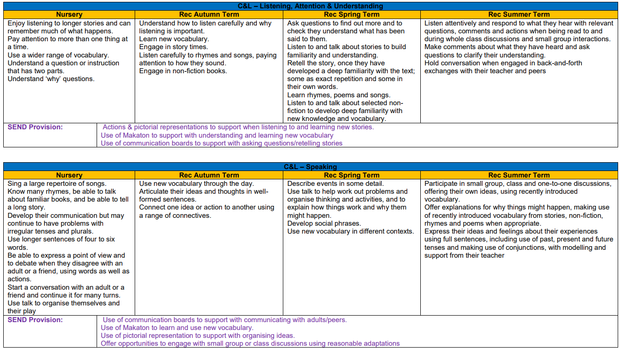
Physical Development
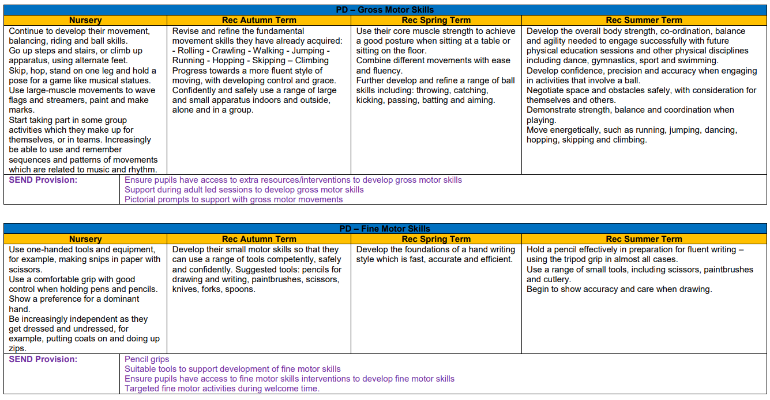

Personal, Social and Emotional Development
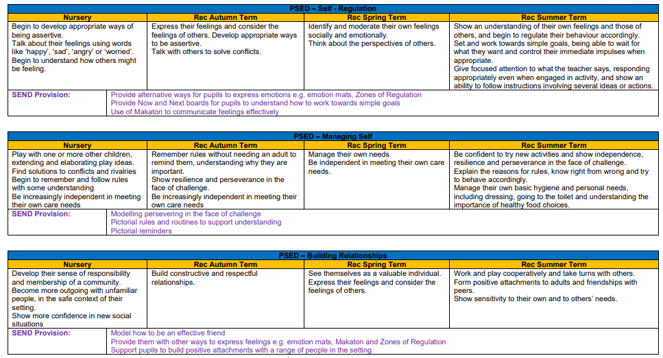

Literacy
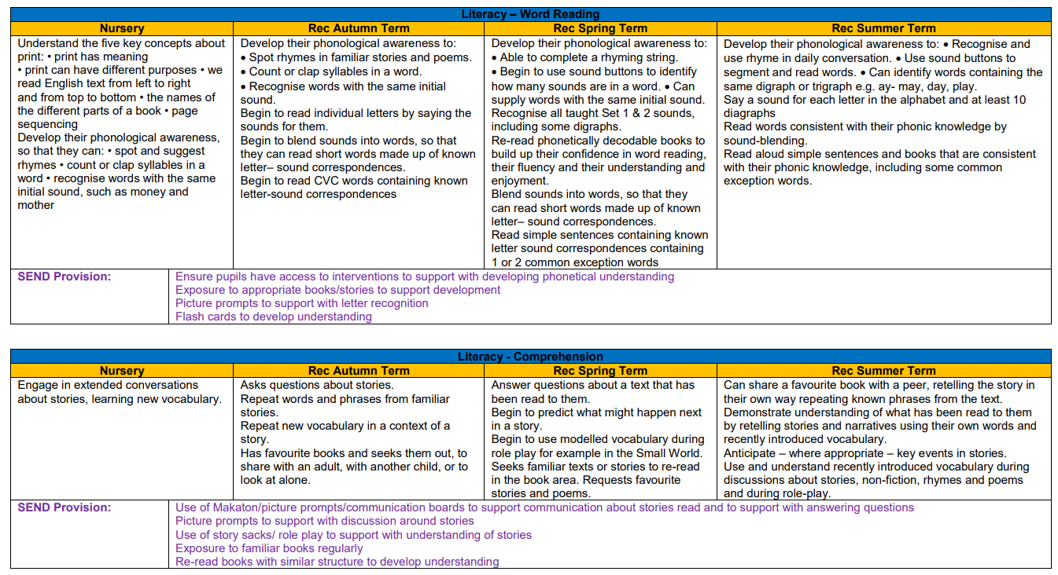

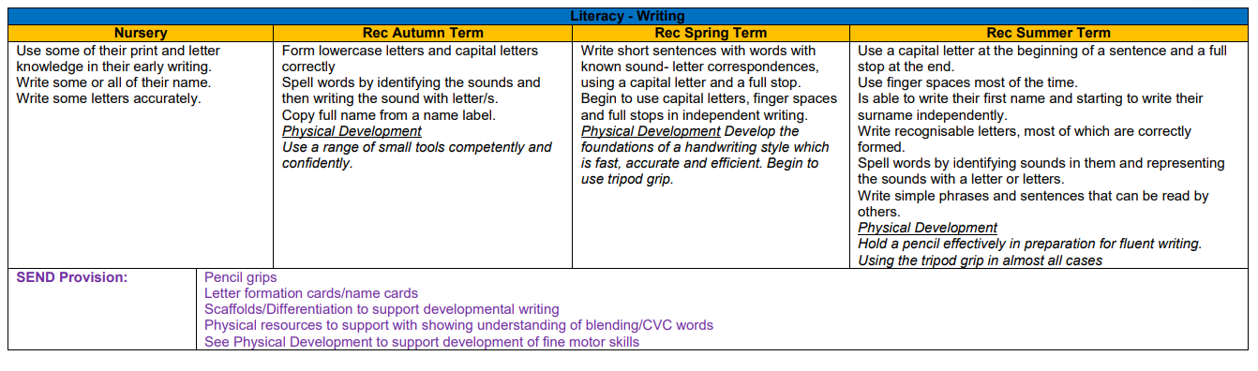

Mathematics
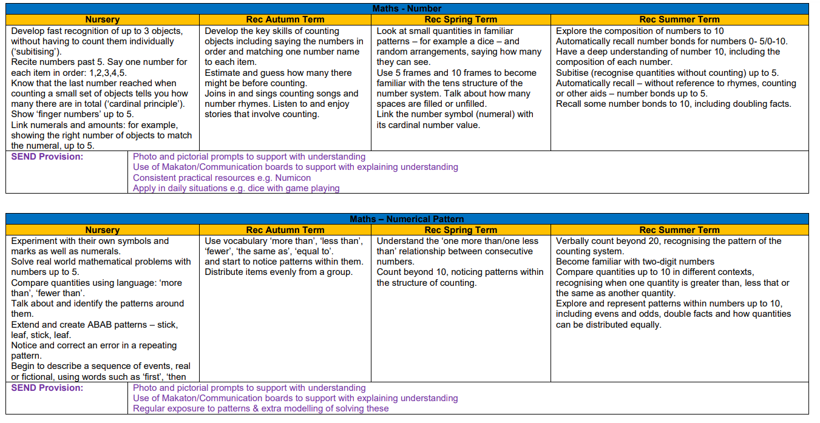

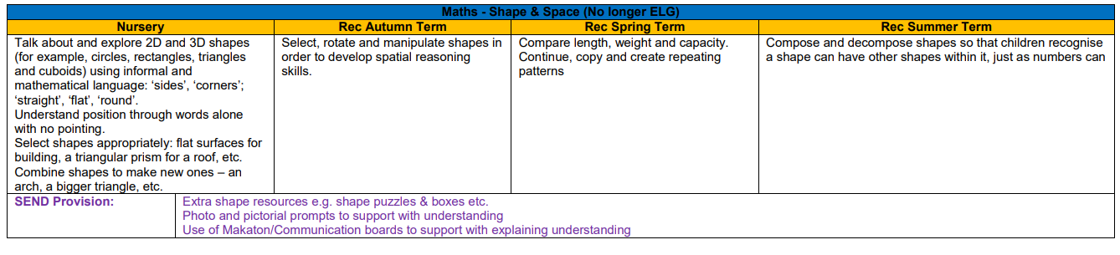

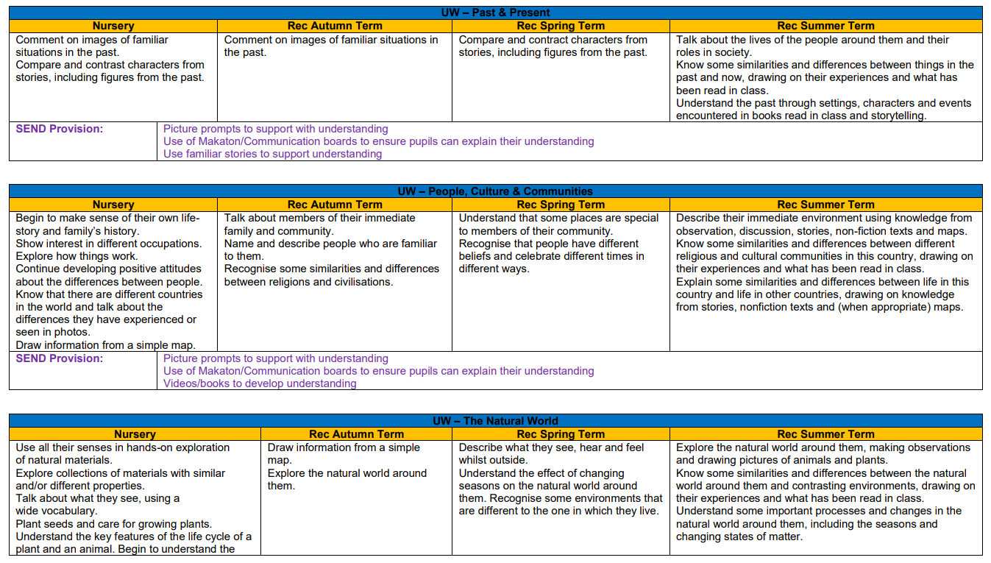
Understanding the World
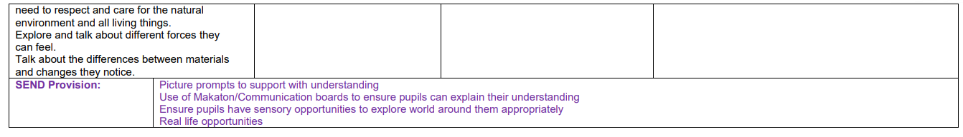

Expressive Arts and Design
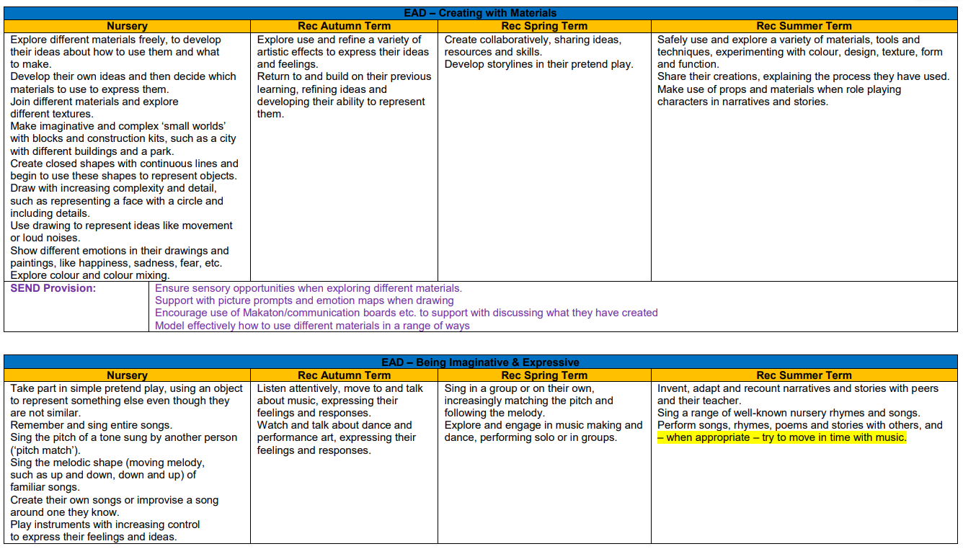
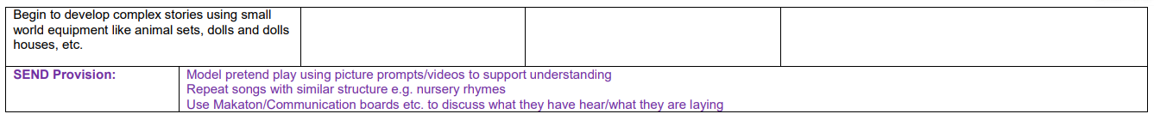

EYFS Computing and Media Links
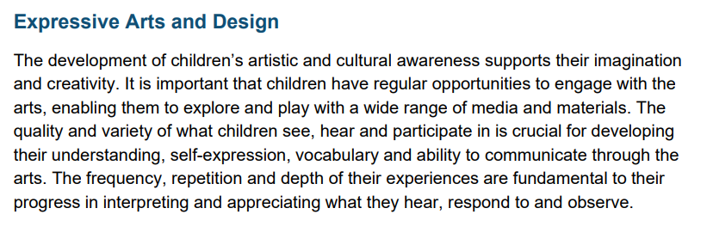
EYFS Statutory Guidance (updated Jan 2024)

Our aims for teaching technology in the EYFS:
Children recognise that a range of technology is used in places such as homes and schools. They select and use technology for particular purposes. It is important in the foundation stage to give children a broad, play-based experience of IT and computing in a range of contexts, including off-computer activities and outdoor play.
IT, in the EYFS, is not just about computers. Our early years learning environment features IT scenarios based on experience in the real world, such as in role play. Children establish the foundation of computational thinking skills either through role-play or cross curricular activities which involve sequence, patterns, logical steps and repetition.
Children gain knowledge, control and language skills through opportunities, which link with topics in the LTP below, such as using media devices to evidence seasonal changes, creating artwork using digital drawing tools and controlling programmable toys.
Relationships established in early play and developing social skills involved in friendships, compassion, and living well together is the underpinning for E-Safety teaching in creating positive social norms online for a respectful online community.
Outdoor exploration is an important aspect and using digital recording devices, such as using cameras and microphones, can support children in developing communication skills.

Autumn 1 | Autumn 2 | Spring 1 | Spring 2 | Summer 1 | Summer 2
E Safety | Autumn walk – IT link (camera) | Seasons – IT link (cameras)  Toys / Hist: Past and Present  IT link (beebots)  Houses and Homes – IT link (devices) | E Safety - Revisit  Seasons IT link (cameras)  Spring | DT: Vehicles IT link (beebots)  Spring into Summer IT link (cameras) | E Safety - Revisit  Summer changes IT link (cameras)
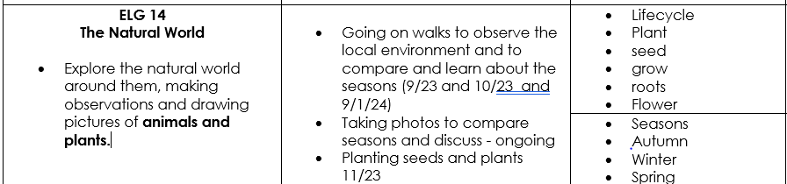
Example of EYFS Science CUSP unit linking to technology:

PE Sequence 2024-2025 (F1&F2)
PE Passport & Whole of Me
Autumn 1 | Autumn 2 | Spring 1 | Spring 2 | Summer 1 | Summer 2
PE Passport  Reception  Dance Nursery Rhymes  (Diwali dance link)  Whole of Me  EY Communicate | PE Passport  Reception  Gymnastics – Flight, Bouncing, Jumping & Landing  Whole of Me  EY Confidence | PE Passport  Reception  Invasion Game Skills 1  Whole of Me  EY Curiosity  EY Empathy | PE Passport  Reception  Net & Wall Game Skills 1  Whole of Me  EY Gratitude  EY Move | PE Passport  Nursery  Dance - Seasons  Whole of Me  Retrieval | PE Passport  Reception  Athletics (taken from Summer 1 plans)  Whole of Me  Retrieval

