Richard Hill C of E Primary School
Maths Policy
August 2024
In a world where number, measurement, geometry and statistics skills are needed in everyday life, we aim to teach all our children vital mathematical skills needed to problem solve and reason. Mathematical knowledge is critical for many subjects including science, technical engineering, computing and is needed in all forms of employment.
At Richard Hill, we recognise that thinking logically and approaching daily problems with perseverance is the key to mastering the National Curriculum. Through the teaching of progressive concrete, pictorial and abstract methods, using the White Rose and Mastering Number Schemes, our children develop a secure understanding of the number system enabling them to become inquisitive, investigative young people who enjoy being challenged. The purpose of this policy is to explain how the school intends to make this provision.
Rationale
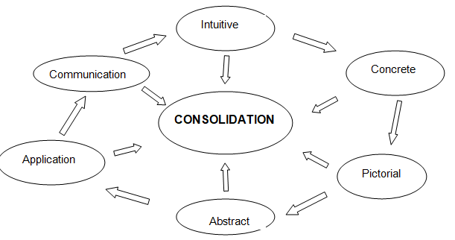
Our school believes:
There is ‘an order that information presented mathematically is processed and learned’.
‘This hierarchy of learning can in turn offer a structure for teachers to follow. Sharma’s research (1990) proposes the following order as effective for the teaching of mathematics to pupils, which requires consolidation at all levels.’
Levels of Learning in Mathematics; NCTEM (2019)

We also believe:
‘Mastery has implications for working memory and long-term memory. The more the basics are practised, the more secure the links with underlying principles. The mastery curriculum in maths is also underpinned by reasoning and there are compelling reasons why reasoning should underpin other aspects of the curriculum as well. Reasoning calls on us to justify, to explain and to make clear our rationale for doing something. It draws on both working and long term memory and supports its nature.’ Mary Myatt; 2018

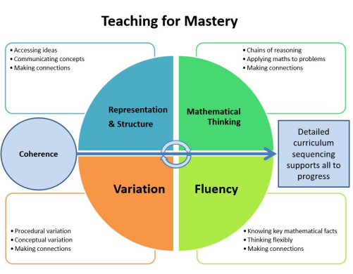
Therefore, Richard Hill’s Maths curriculum is designed around the Mastery Approach. Using the NCETM and Maths Hub research into “The Five Big Ideas”, and the EEF’s research into improving Mathematics in Key Stage 1 and Key Stages 2 and 3, we have created an agreed lesson structure to ensure all parts of the teaching for mastery diagram is embedded into our teaching.
The Five Big Ideas; NCETM (2017)
See appendix 1 for Richard Hill’s “Agreed Lesson Structure”

Aims:
The school’s aims are to:
- Teach progressive concrete, pictorial and abstract methods to enable all children, including those with SEND or disadvantaged backgrounds, to become fluent in key mathematical concepts
- Challenge our children’s thinking through rich and sophisticated problems so they are able to reason, find generalisations and proof
- Meet the requirements of the national curriculum programme of study for maths
- Strengthen our children’s long-term memory by following planning which provides spaced, interleaved and retrieval practice in line with our T&L policy and CUSP curriculum
- Embed children’s communication and problem-solving skills into the wider curriculum
- Foster a sense of enjoyment and enthusiasm for the nature of mathematics to ensure children continue to develop and master concepts later in life
- Ensure children with mathematical proficiency are celebrated
At Richard Hill, we follow the National Curriculum for mathematics to ensure that all pupils:
- Become fluent in the fundamentals of mathematics, including through varied and frequent practice with increasingly complex problems over time, so that pupils develop conceptual understanding and the ability to recall and apply knowledge rapidly and accurately
- Reason mathematically by following a line of enquiry, conjecturing relationships and generalisations, and developing an argument, justification or proof using mathematical language
- Can solve problems by applying their mathematics to a variety of routine and non-routine problems with increasing sophistication, including breaking down problems into a series of simpler steps and persevering in seeking solutions

INTENT
The mathematics curriculum offers the opportunities for children to develop their learning behaviours, in line with our Six Strands:
Boundaries: I respect others reasoning, share resources with peers, cope when I get an answer wrong and ask for help when needed.
Resilience: I can cope when I get an answer wrong, ask for help when needed and listen to respond to feedback to improve my learning.
Focus: I can follow and carry out instructions given to me and remain on task.
Respect: I can prepare and tidy away independently, use equipment safely and always be respectful of my working environment.
Self-Regulation: I can calmly work my way through problems, accept when I have made a mistake and respond appropriately during lessons.
Independence: I am eager to learn, can start and finish my word independently and know how to use the resources and environment for support.
As stated in our Teaching and Learning Policy, teachers use “Responsive Teaching” techniques such as questioning, retrieval practice and effective feedback to assess if learning has stuck or if teaching needs to be adapted to meet need.
Breadth & Depth; Curriculum Planning
‘Having considered longer-term views of learning we aim to revisit critical ideas, reinforce others, relate new material to that where understanding is already relatively secure, and connect the acquisition of knowledge and understanding to appropriate skills.’ (Husbands & Pierce 2012)
White Rose
We use the White Rose scheme of work, which sets out a progression for learning based on the belief that, given the right opportunities, every child can succeed in Maths. This is termed a Mastery approach; rather than rote-learning methods, children develop a deep understanding of mathematical concepts, creating a solid foundation on which to build future learning.
Long Term Planning
For mathematics in our school, long term planning is based on the programmes of study set out by the National Curriculum from EYFS to Year 6. Richard Hill’s maths grids have been created using the “Birth to 5 Matters” document (EYFS Shape, Space and Measure), the NCETM’s Mastering Number Programme (EYFS Number) and the NC for Years 1-6 to ensure all age-appropriate objectives are met. These grids ensure NC areas are covered for each year groups whilst teaching in mixed age classes. These can be found on our school website.
Medium Term Planning
Mastering Number termly overviews are used to ensure the foundation of number are taught in the EYFS (see Appendix 2). White Rose term by term planning (see Appendix 3), specifically designed for mixed age classes, is used to ensure coverage, continuity and progression. We believe this is in line with the National Curriculum expectations for each Key Stage and ensures fidelity to the scheme. However, in some cases, plans and units of work have been added or moved to allow the children to revisit and consolidate previous units, and to build on their prior knowledge and memory retrieval skills.
Term by term plans may also be adapted depending on how many weeks are in each term per academic year, and whether cohort characteristics require teachers to plan lessons depending on the learning that has been mastered.
Short Term Planning:
Short term planning is completed weekly on IWB slides. For the EYFS, these slides have been created by the NCETM. Teachers use the calculation policy to ensure methods are progressive (see Appendix 4) and White Rose planning documents to ensure fluency, reasoning and problem-solving opportunities are provided for each NC objective.
A daily maths agreed lesson structure (Appendix 1) must include:
- Connect - Flashback 4
- Let’s unpick together… - SATS style question
- Connect – Review of previous lesson
- LI & “A mathematician can” …
- Vocabulary
- Explain
- Example
- Attempt
- Apply
- Challenge
- Next steps for learning
Teaching & Learning (STP expectations E.g. LI/ SfS / memory retention strategies)
As sighted in our school’s Teaching and Learning Policy, we believe knowledge of the pupils; their prior attainment and specific needs, is a key part of planning. Additional research-based strategies below have been added to strengthen teacher’s subject knowledge of maths, and to ensure every maths lesson targets children’s working and eventually long-term memory, mirroring our CUSP curriculum:
Mastering Number KS2
“Fluent computational skills are dependent on accurate and rapid recall of basic number bonds to 20 and times-tables facts. The LPS schools have found that spending a short time every day on these basic facts quickly leads to improved fluency and that this has helped children develop a strong sense of number relationships, an important prerequisite for procedural fluency.”
NCETM; Calculation Guidance for Primary School’s document (2015)
Here at Richard Hill, we use the NCETM Mastering Number scheme across the school, as we believe this develops children’s conceptual understanding through identifying patterns and relationships of number.

Flashback 4s
The National Curriculum aims for all children to ‘become fluent in the fundamentals of mathematics, including through varied and frequent practice with increasingly complex problems over time, so that pupils develop conceptual understanding and the ability to recall and apply knowledge rapidly and accurately’. Flashback 4 is a daily starter activity consisting of one question each from a topic covered last lesson, last week, two or three weeks ago and last term or last year. This is to encourage children to revisit learning and to aid the quick recall of previously taught knowledge and skills.
Key Vocabulary
A factor that can affect a child’s learning is their level of language competency. Because of this, teachers clarify a range of general, technical and academic mathematical language to ensure our children can understand problems and articulate a verbal response. This in in line with our expectation for children to learn and use ambitious language in all subject areas.
Teacher Modelling
This policy’s Rationale mentions Sharma’s research (1990), suggesting there is ‘an order that information presented mathematically is processed and learned’. Lucy Rycroft-Smith and Camilla Gilmore also considered the evidence around working memory in mathematics learning, and they found ‘Classroom strategies such as using manipulatives, repetition, and breaking down tasks into smaller steps may help to reduce working memory load.’ Cambridge Mathematics; 2017. Therefore, when modelling, our teachers use concrete, pictorial and/or abstract representations to ensure there is an order of thinking. Teaching of mathematical also follows the school’s T&L policy using the “I do, we do, you do” integrated metacognitive approach.
Using & Applying (U&A) lessons
Ponte’s research into exploring and investigating in mathematics teaching and learning, found that investigations are a significant part of the mathematics curriculum as they ‘stimulate holistic thinking’ and promote ‘complex thinking but reinforce learning elementary concepts’. As a school, the maths subject lead teaches a termly U&A lesson as part of our “curriculum days” to ensure our children are given opportunities to enquire and to apply their mathematics to a variety of routine and non-routine problems systematically. U&A style lessons are also embedded into the White Rose lessons as part of reasoning practice.
Marking and Feedback
All pupils receive feedback on their work (verbal and/or written). The marking policy in our T&L police is adhered to across the school to ensure marking is purposeful and consistent for our children.
Links with other subjects
Mathematics contributes to many generic skills needed across the curriculum such as communicating, reasoning and problem solving. We also encourage children to use and apply specific mathematics taught in other areas of the curriculum.
See below how we ensure cross curricular links are made:
Science | Using weights and measures whilst learning to use and apply number skills  Through investigations; learning to estimate and predict  Developing the skills of accurate observation and recording of events using numbers in many of their answers and conclusion
Geography | Representing objects with maps  Studying space, scale and distance  Learning how to use four- and six-figure grid references  Using graphs to explore, analyse and illustrate a variety of data
Design & Tech | Learning how to measure accurately and how to check their results  Applying their knowledge of fractions and percentages to describe quantities and calculate proportions  Learning to read and interpret scales, collect and present data and draw conclusions  Learning about size, shape and drawing scaled drawings
PE | Using number to score  Creating league tables and interpreting data
History | Reading timelines and calculating lengths of historical periods  Mapping areas of invasion / conquering
Maths | Understanding pattern when following a repeated sequence  Counting sets of beats
Reading | Reading fictional information involving graphs, diagrams and number

Early Years
‘Direct teaching may be necessary, but effective early mathematics teaching strategies are playful, not formal, so that all children become cheerful, not fearful mathematicians.’ Gifford, S. (2018)
Our school believes the first few years of a child’s life are vital when building firm mathematical foundations. To ensure our children master these basic skills, we use the NCETM Mastering Number Programme to teach the following key areas:
- Cardinality and Counting: understanding that the cardinal value of a number refers to the quantity, or ‘how-many-ness’ of things it represents
- Comparison: understanding that comparing numbers involves knowing which numbers are worth more or less than each other
- Composition: understanding that one number can be made up from (composed from) two or more smaller numbers
- Pattern: looking for and finding patterns helps children notice and understand mathematical relationships

We use the Maths grids created from The Birth to Five Matters document to ensure the following key areas are taught:
- Shape and Space: understanding what happens when shapes move, or combine with other shapes, helps develop wider mathematical thinking
- Measures: comparing different aspects such as length, weight and volume, as a preliminary to using units to compare later.
Taken from Key Concepts; NCETM (2018)
EYFS progression into KS1:
For a smooth transition and to ensure explicit fluency learning is taught, KS1 also use calculation methods suggested by the NCETM Mastering Number Programme.

Assessment & Monitoring
At Richard Hill Primary School, we follow our Trust’s LearnAt Assessment Framework.
Standardised Tests (Rising Stars – PUMA and PIRA and GaPS) are conducted three times a year – in the two weeks preceding a summative assessment point.
The results of these tests inform:
• an evaluation of the progress pupils make throughout the year and year-on year
• moderation and bench-marking of standards and expectations across year groups within schools and between trust schools.
• triangulation of the evidence available to inform teachers’ summative assessment judgements.
• Formative assessment of whole class and cohort gaps in learning and misconceptions to inform teachers’ planning for future teaching and learning and school leaders’ planning for professional learning and school improvement.
National tests and statutory assessments in Maths are conducted in the year groups and at the points dictated by the DfE.
AfL strategies within each lesson enable teachers to intervene quickly when a child requires additional support or when further challenge is needed. To ensure fidelity to our White Rose scheme of work, we also use end of unit mini assessments to ensure taught concepts have been mastered before moving on, and those children who are efficient in methods are being challenged. We believe this creates a mastery approach to learning.
Children needing interventions are identified during termly Progress and Consistency Meeting and progress for every child is tracked rigorously. If necessary, units of work are extended or revisited to ensure mastery of that year group objective.
The Maths Coordinator monitors this data to evaluate teaching and learning of mathematics across the school, providing appropriate CPD for teaching staff to ensure attainment and progress are raised.

Equal Opportunities & Inclusion
As our school T&L Policy states, our belief is that education is transformational. Our role is to support all our pupils to succeed irrespective of their starting points.
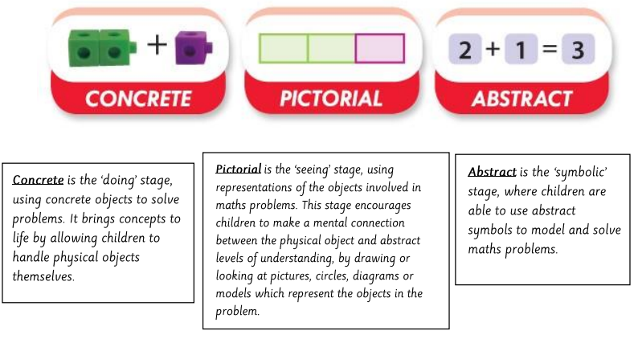
Richard Hill’s Calculations Policy has been designed to be ambitious and meet the needs of all pupils, including those with SEND and disadvantaged backgrounds, to ensure they achieve the best possible outcomes. Concrete and pictorial methods allow all children engage in age related maths problems with increasing fluency and independence. The Mastery Approach used in our teaching also ensures all children are encouraged to reach their full potential in every lesson.

Children are encouraged to use the correct mathematical vocabulary and use sentence stems to help shape their answers and explain their reasoning. Working walls are used to support learning and include key vocabulary and useful strategies.

High Expectations and Love of Mathematics
Every year, Richard Hill has a Maths challenge in the Spring term, focusing on the following areas for each year group:
Number bonds to and within 10 – Year 1
Number bonds to and within 20 – Year 2
Multiplication facts 2x, 10x, 5x, 3x, 4x, 8x tables – Year 3
Multiplication facts up to 12x – Year 4
Multiplication and Division facts up to 12x – Year 5
Arithmetic challenge – Year 6
A collective worship launches the competition, reminding the children how to be a good mathematician and the importance of maths in everyday life. All the children then have the opportunity to strengthen their number facts through added mental maths lessons, and children are motivated by the challenge.
Children who score 19/20 or 20/20 are celebrated in whole school assemblies for their proficiency.
Parental Resources
We have developed strong partnerships with parents and carers to ensure they encourage their children to use the progressive methods in our calculation policy. We believe this gives our children consistency when completing mathematical tasks at home.
Parents are also kept informed about mathematics at Shenton Primary via:
- Parent welcome meetings
- KS1 Mastering Number Workshops
- Parents evenings
- Written reports at the end of the academic year
- School website
- Maths Policy, including Calculations Policy
- KS1 Workshop key messages
- KS2 Timetable Rock Stars
- Links to White Rose Parent Leaflets
Resources
The school acknowledges the need to continually monitor and develop mathematical resources. Each class must have their own sets of equipment needed to ensure the calculation policy methods are taught effectively.
Electronic copies of Power Points and webinars for the Mastering Number Programme, White Rose fluency planning and other interactive resources are available for teachers to use. All can be found on the White Rose website in which teachers have access to.
Practical equipment such as rekenreks, base 10, place value counters, number cards, play money, number lines, bead strings, various counting objects and measuring apparatus are purchased as and when needed in consultation with the Maths coordinator and Trust.

Appendix 1: Richard Hill’s Agreed Lesson Structure and “A mathematician can…”

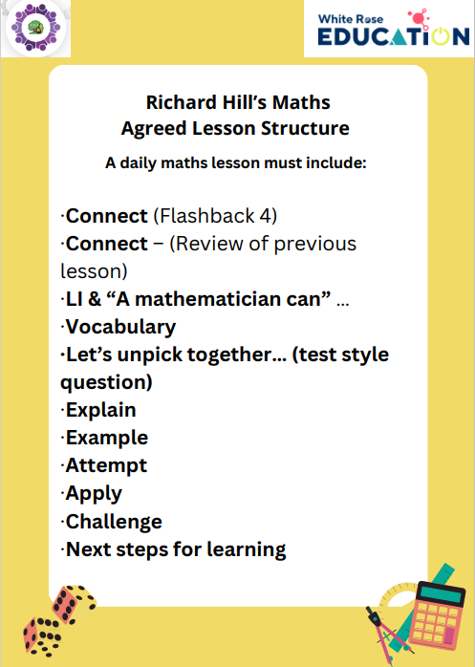

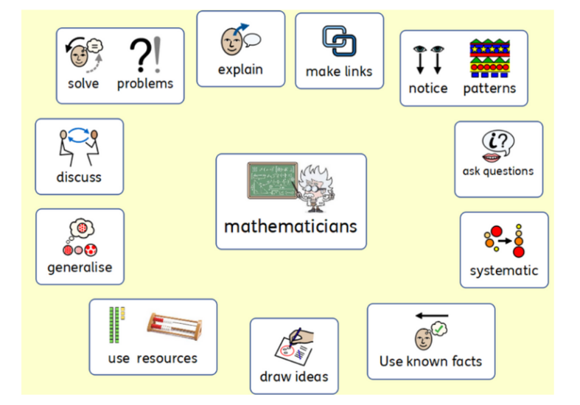

Appendix 2: EYFS Mastering Number Programme; Term by Term Planning
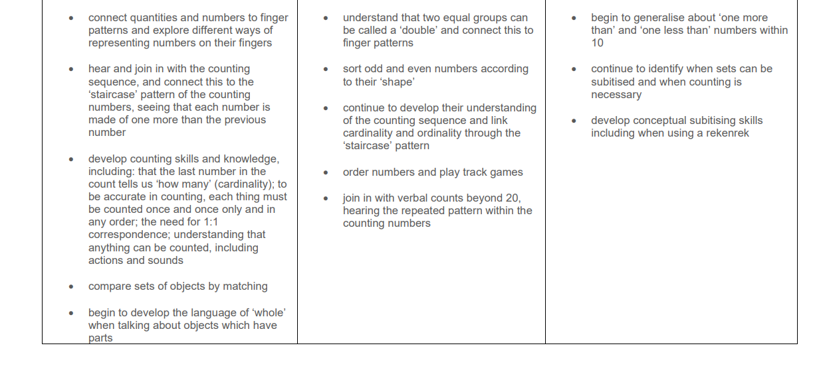
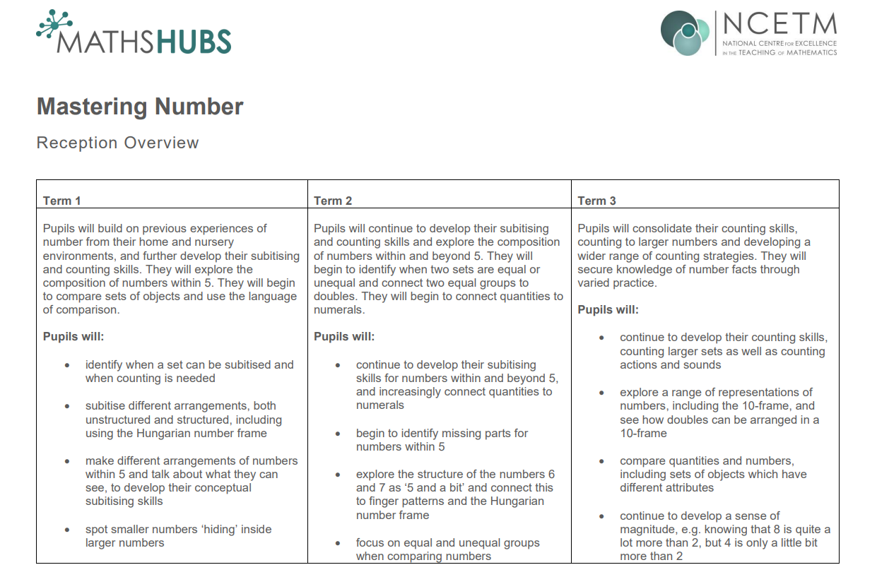

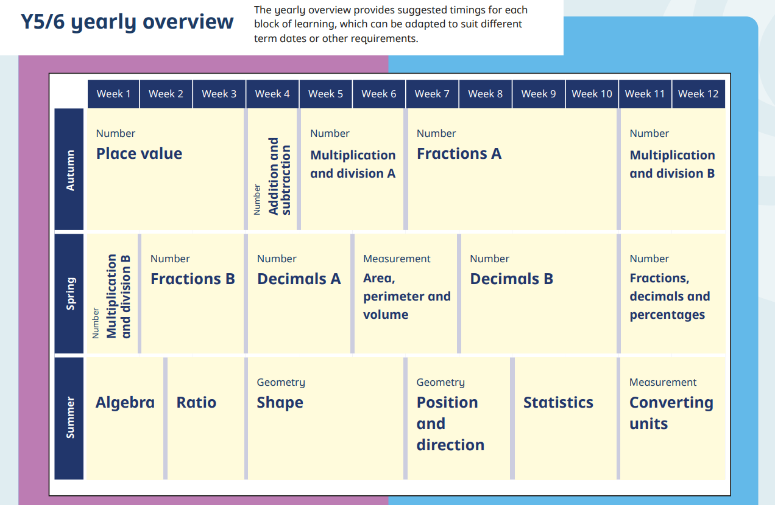
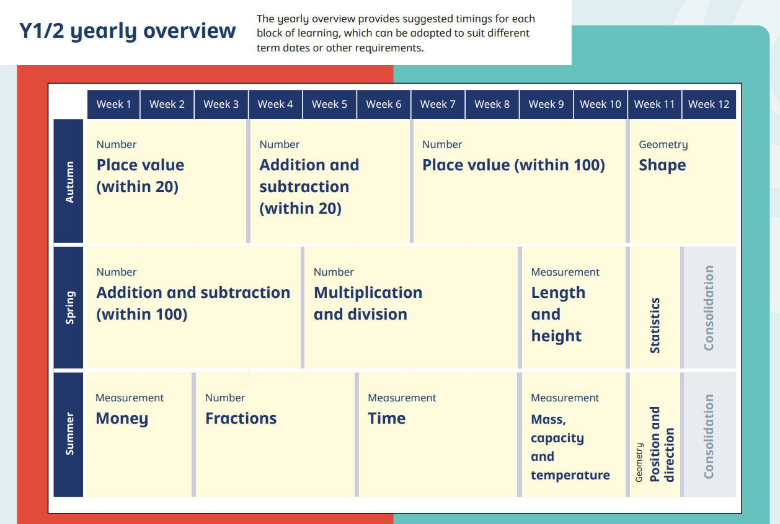
Appendix 3: Years 1-6; Term by Term Planning
This will be adapted depending on term dates / cohort needs



